BUNDOORA FAMILY CLINIC
Digital Prescription and Pharmacy Management System
System Frontend
Administrator · Doctor · Pharmacist · Patient

Document | User Manual
Version | 1.0
Date | September 2026
Prepared by | [Puja Gurung / Yam Mohatra / Darpan Kafle]
Unit | Capstone
Status | Final

1. A complete Guide To System Frontend

1.1 Homepage
Open a web browser and navigate to the clinic portal address provided by the clinic (for example, http://localhost/bundoora-family-clinic-html/ in the local test environment). The homepage introduces the clinic's services and provides links to sign in and to register as a patient.

[Code]

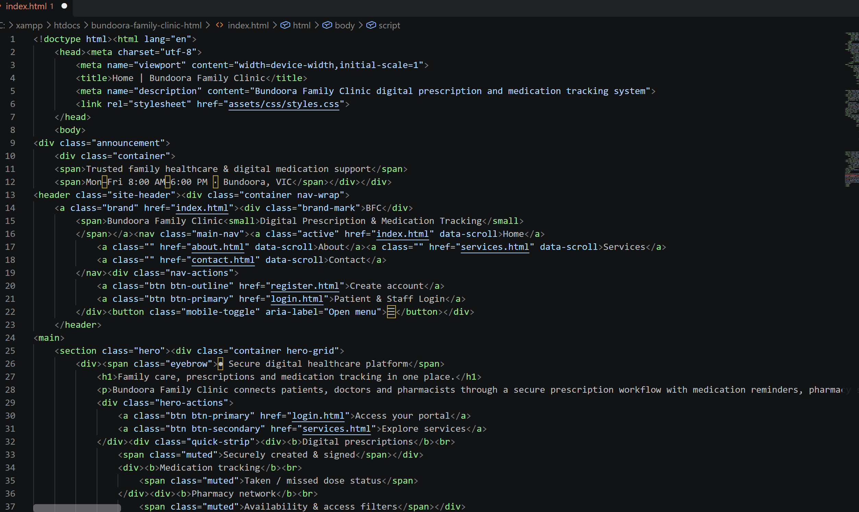
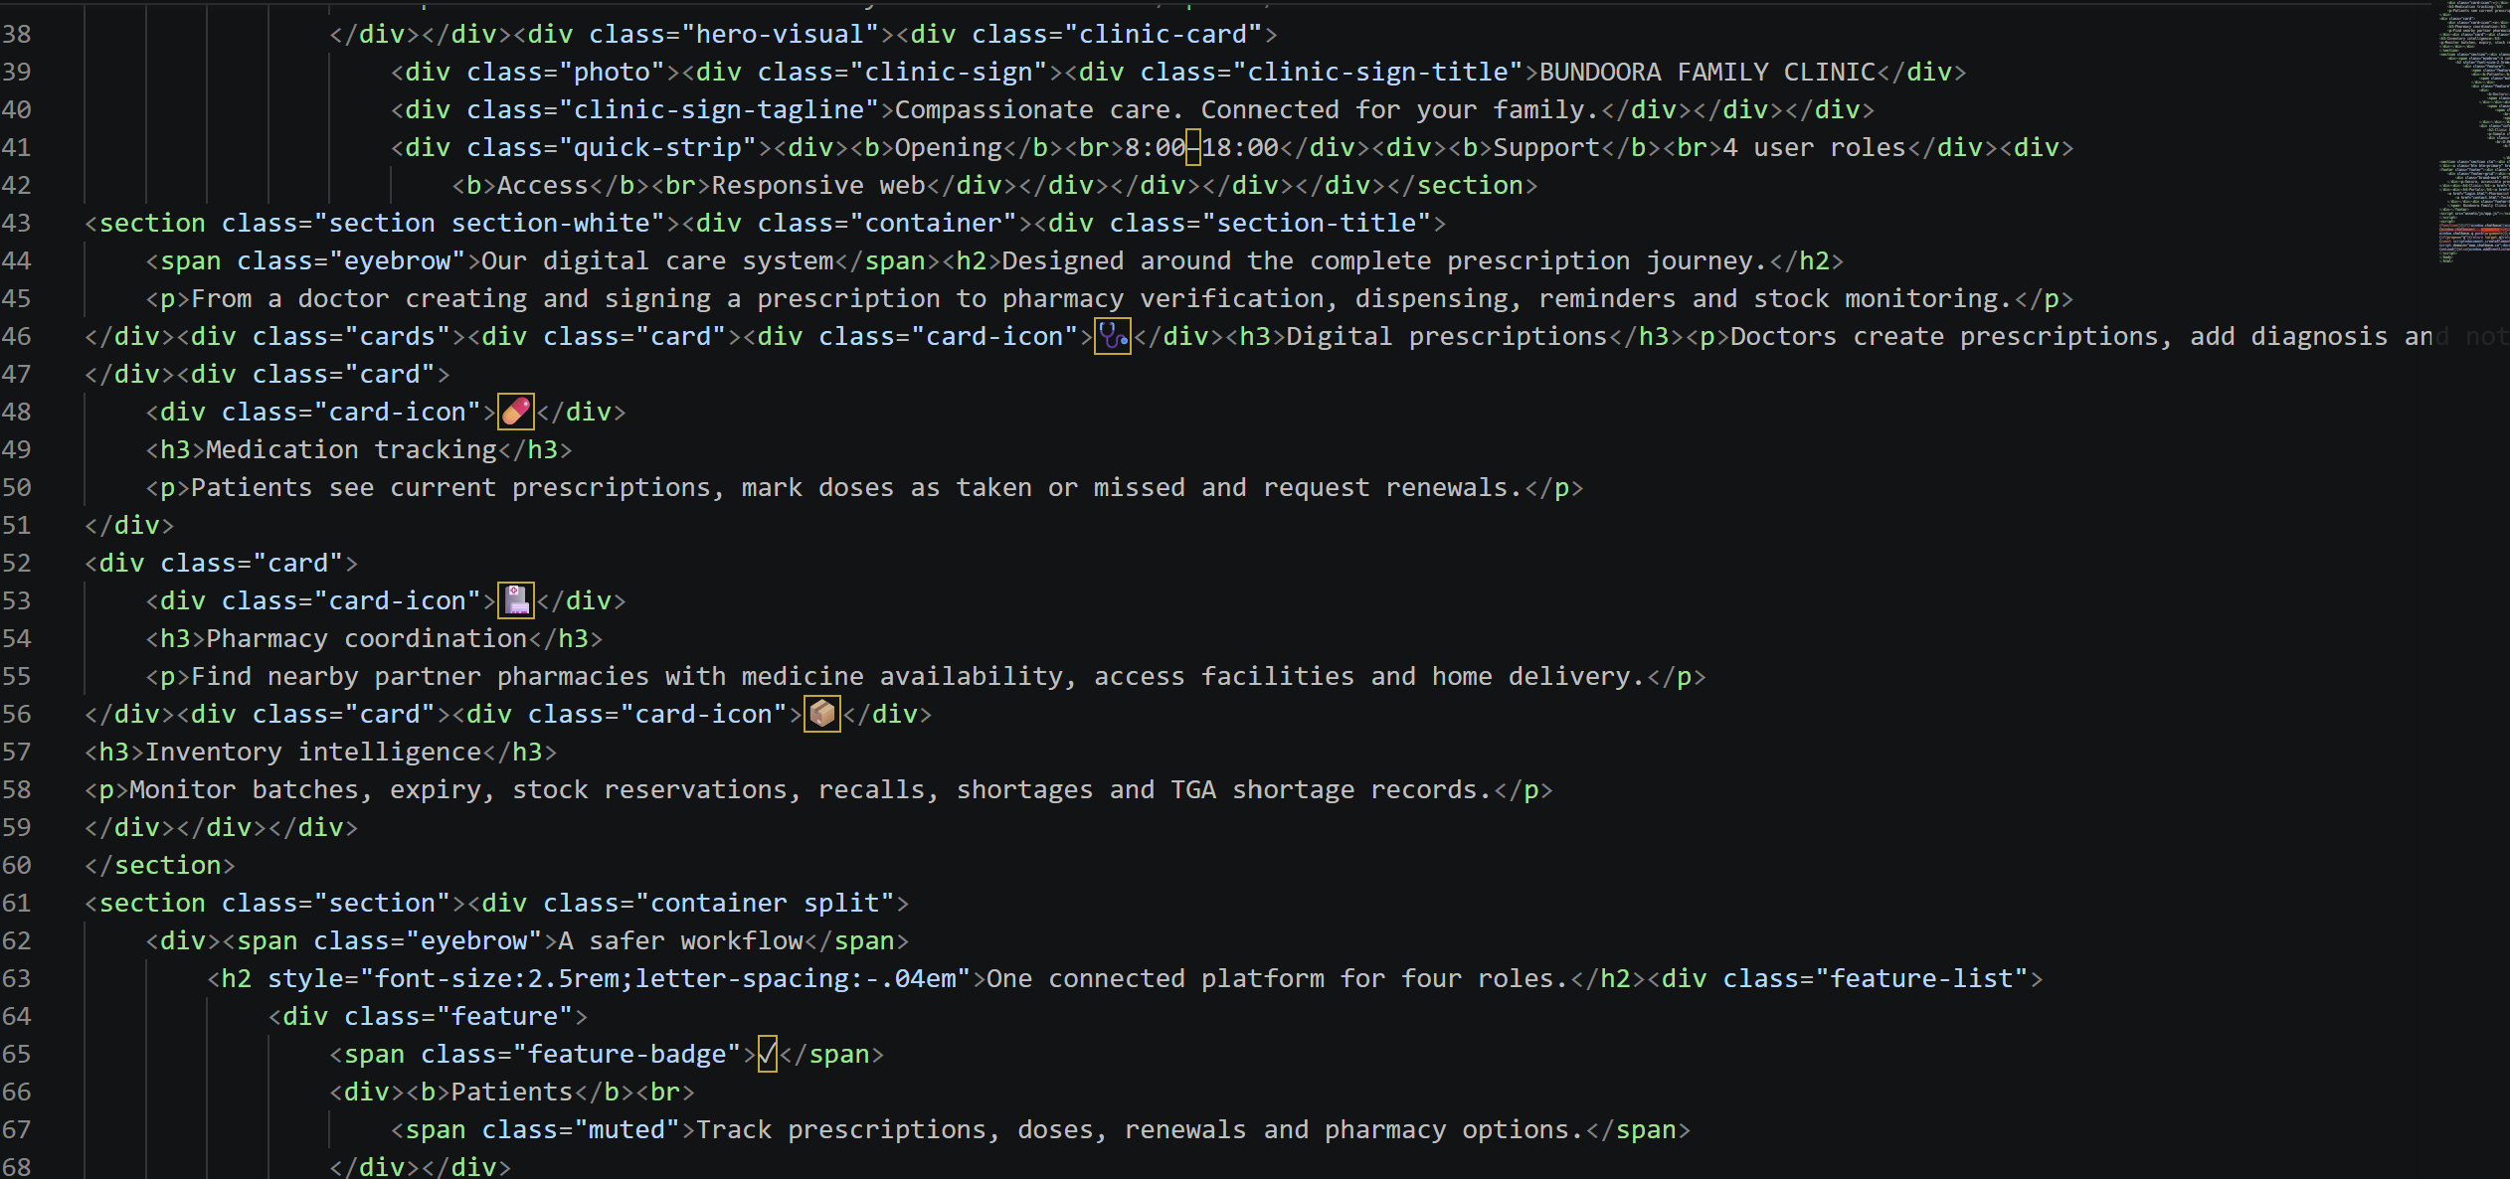
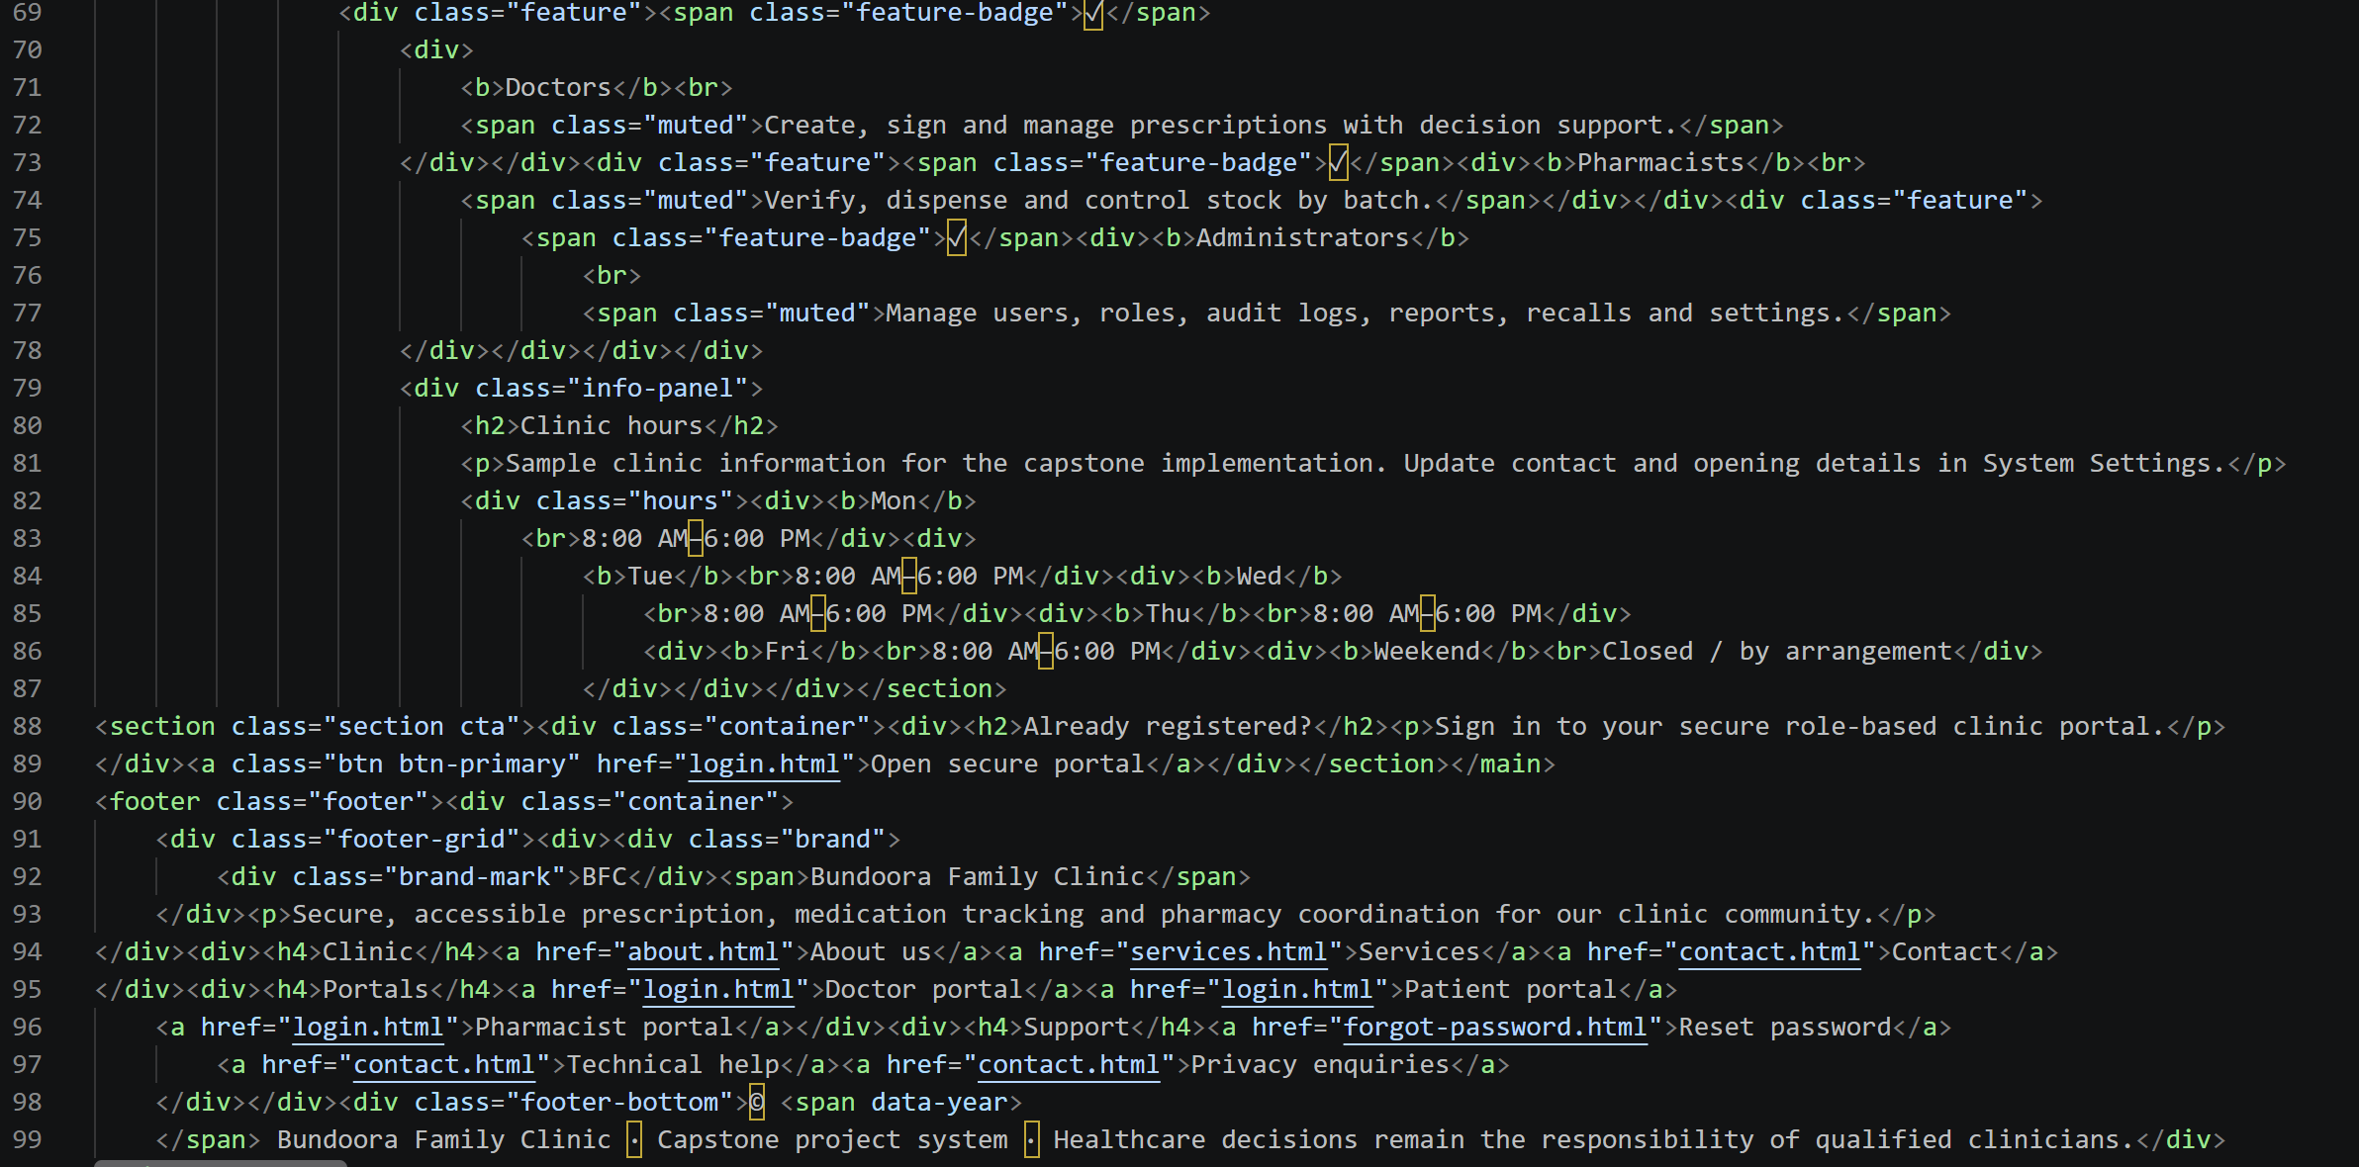
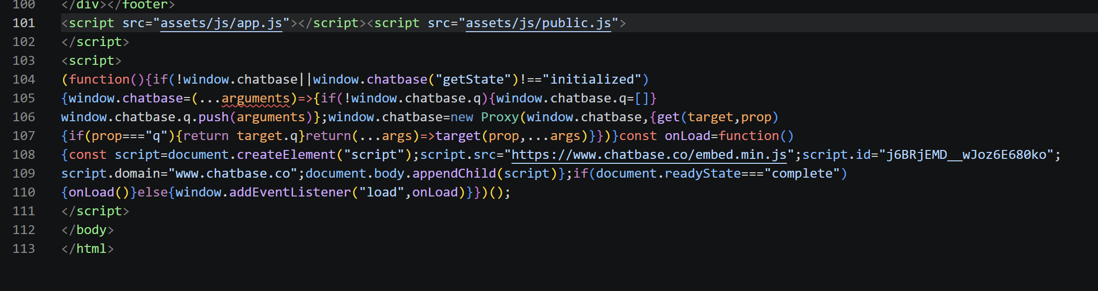

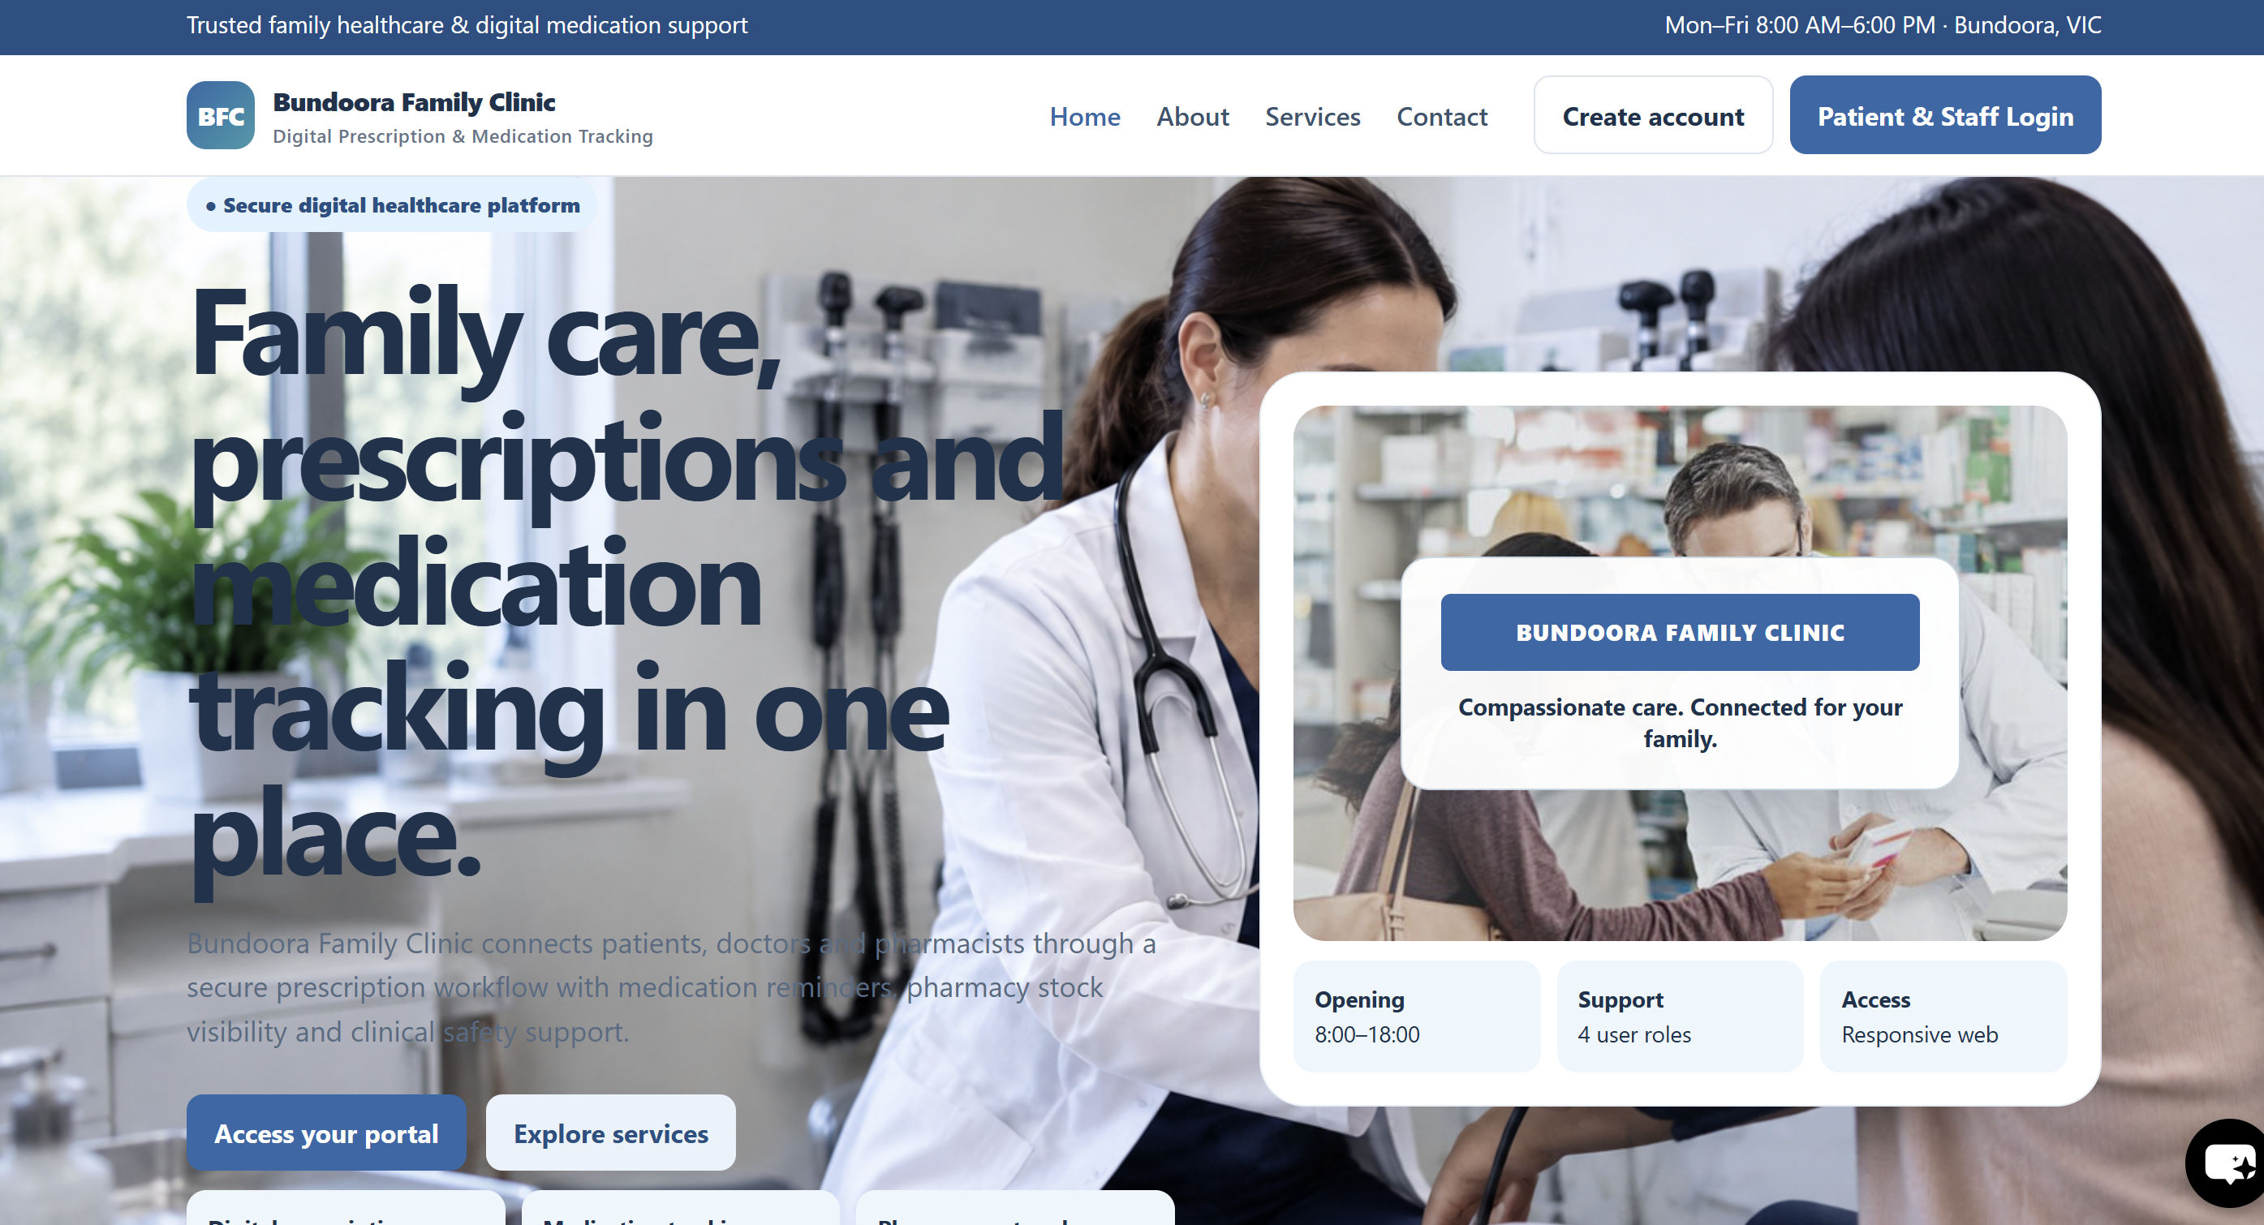
Fig: Clinic homepage

1.2 Registering a Patient Account
Public registration is available to patients only. Doctor, Pharmacist and Administrator accounts are created by an Admin.

[Code]
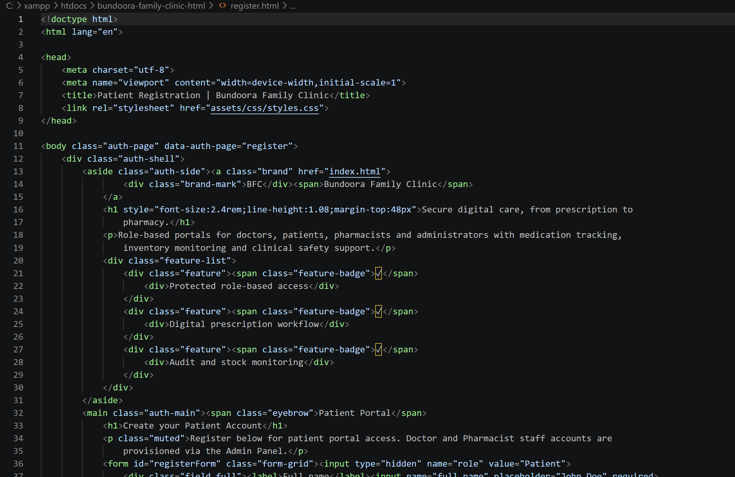
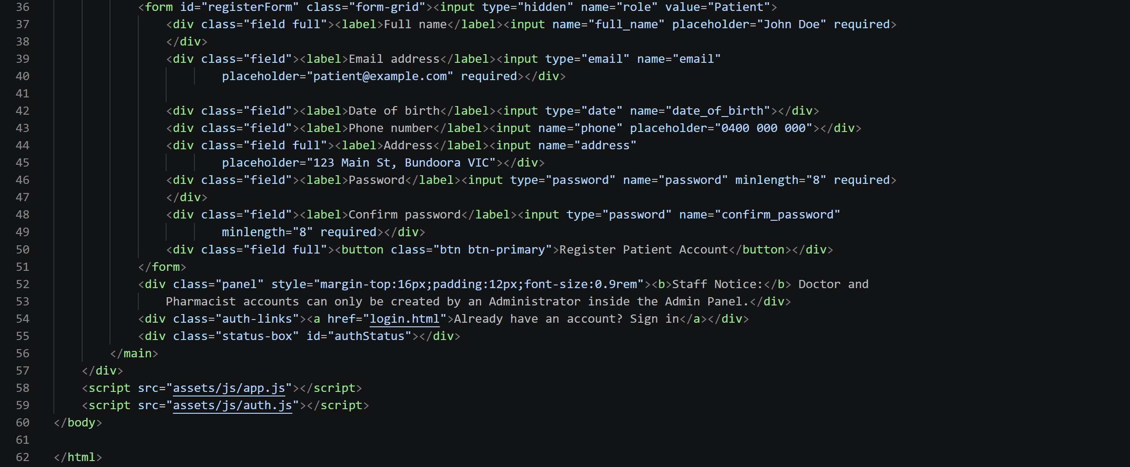

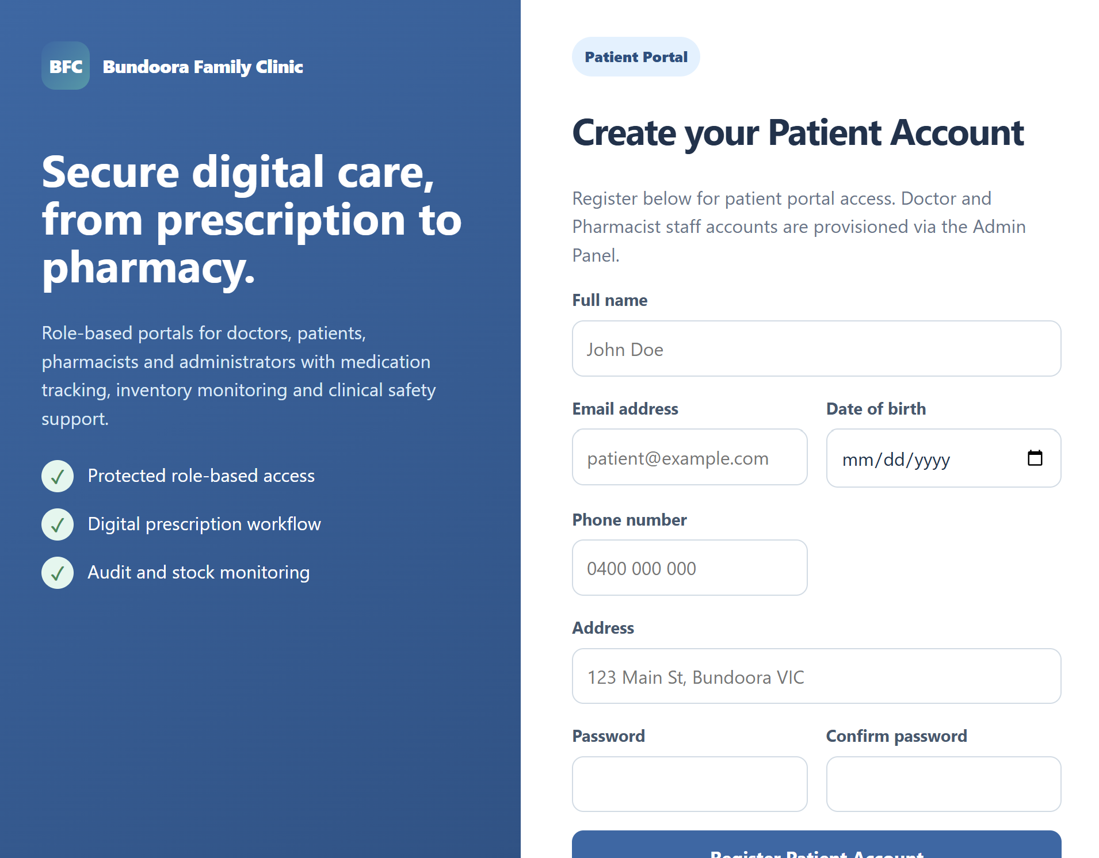

Fig: Registration fields

1.3 Signing In

[Code]
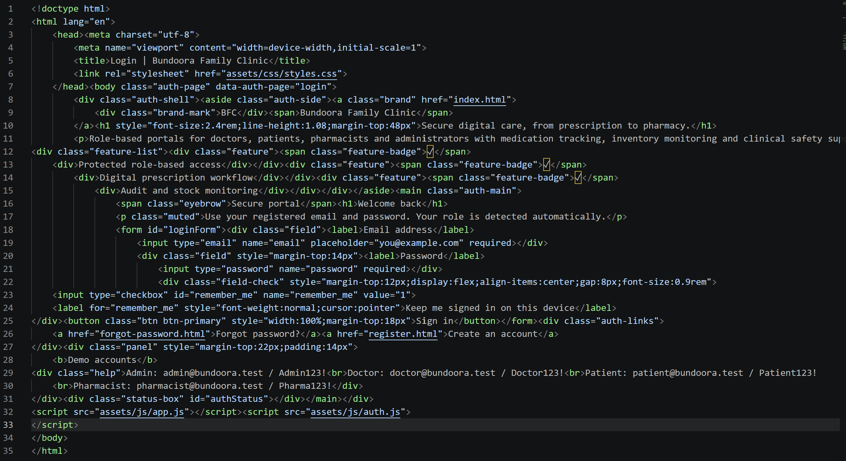
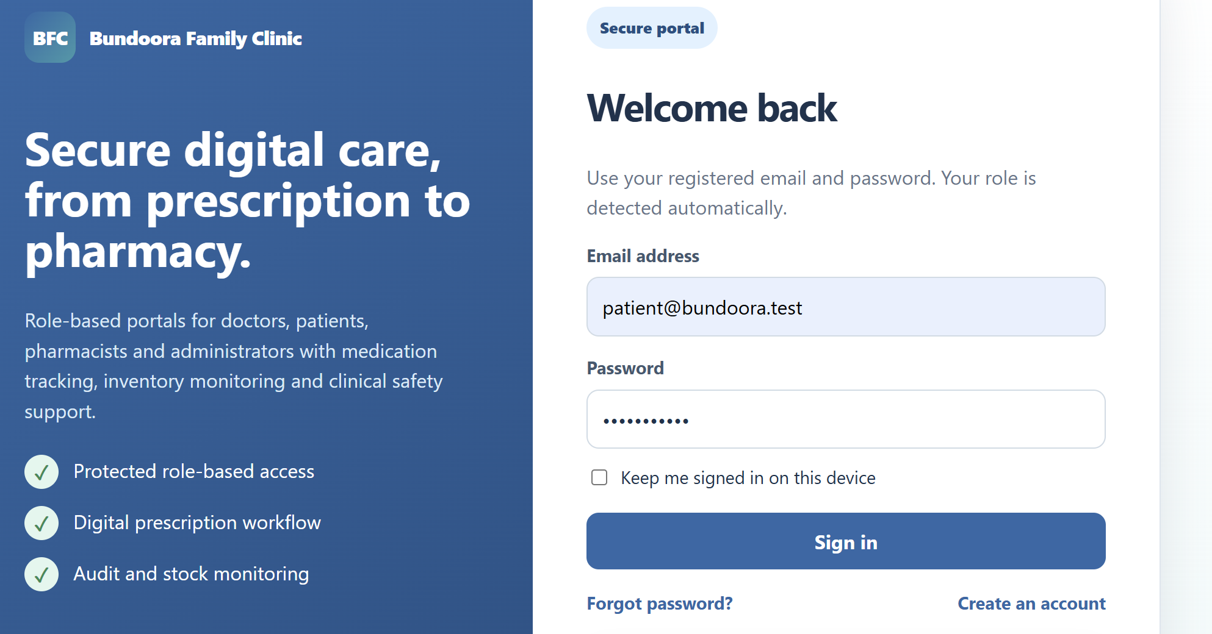Figure : Sign-in page

1.4 Resetting a Forgotten Password

[Code]
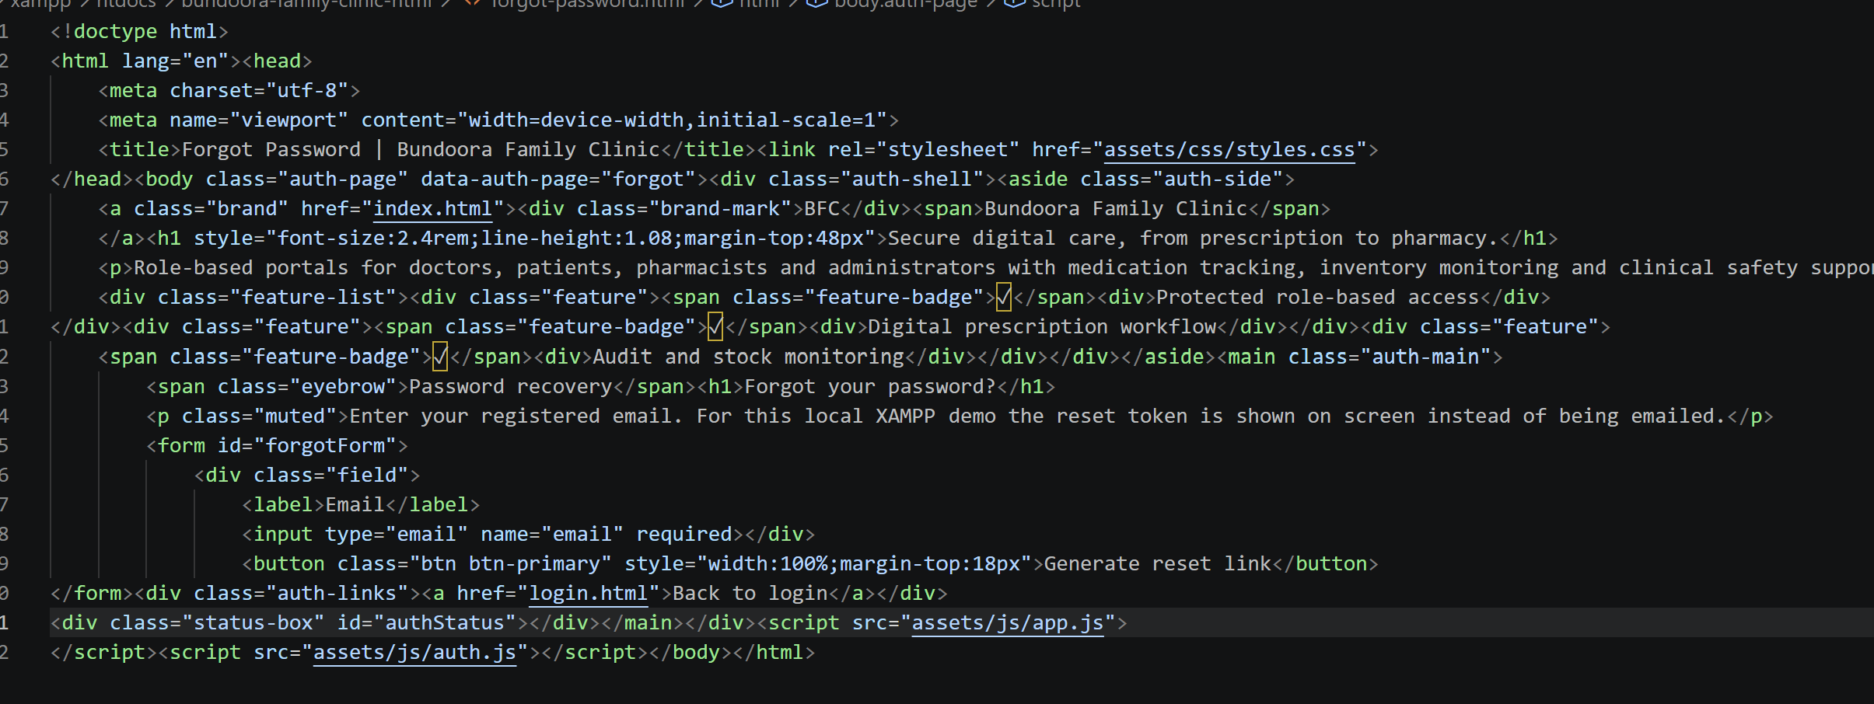

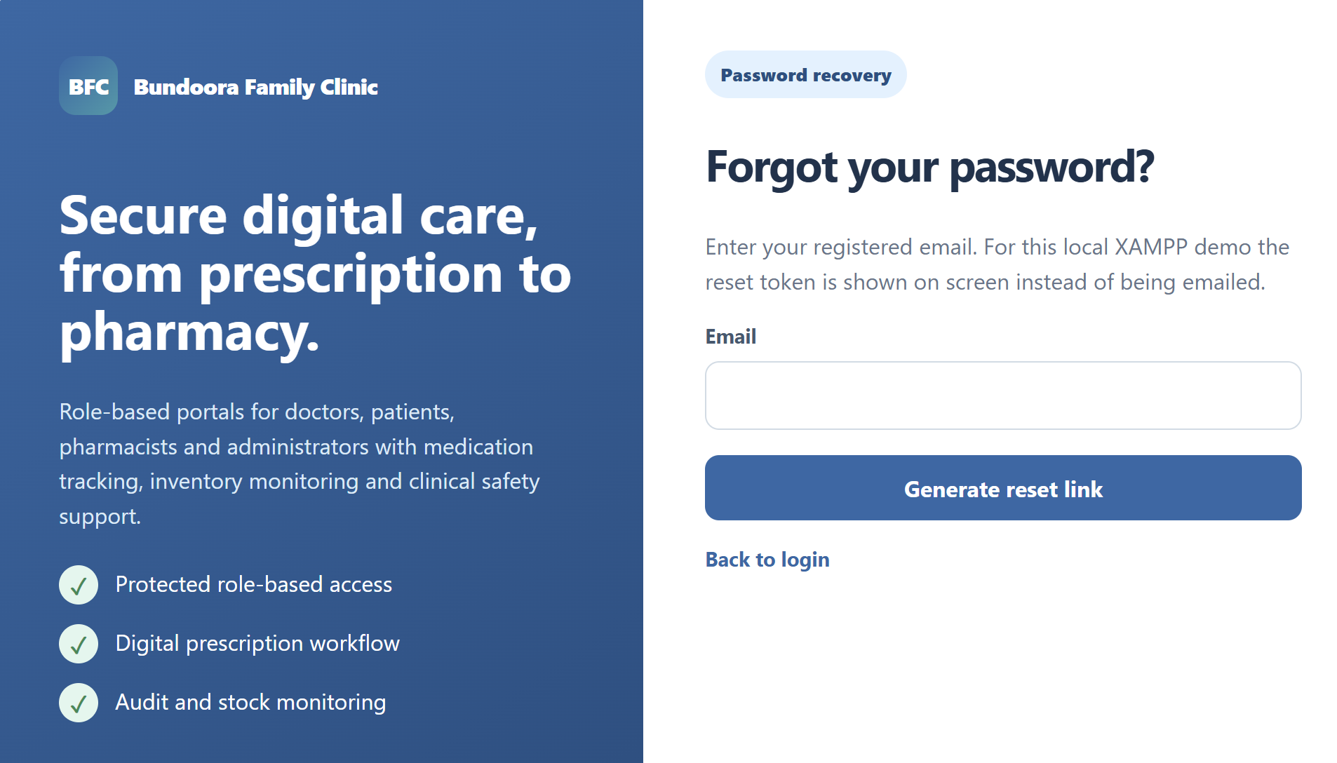

1.5 Session Timeout and Signing Out
For security, the system signs users out automatically after a period of inactivity set by the Administrator. To sign out manually, select Logout from the top bar.

1.6 Portal Layout

[Code]
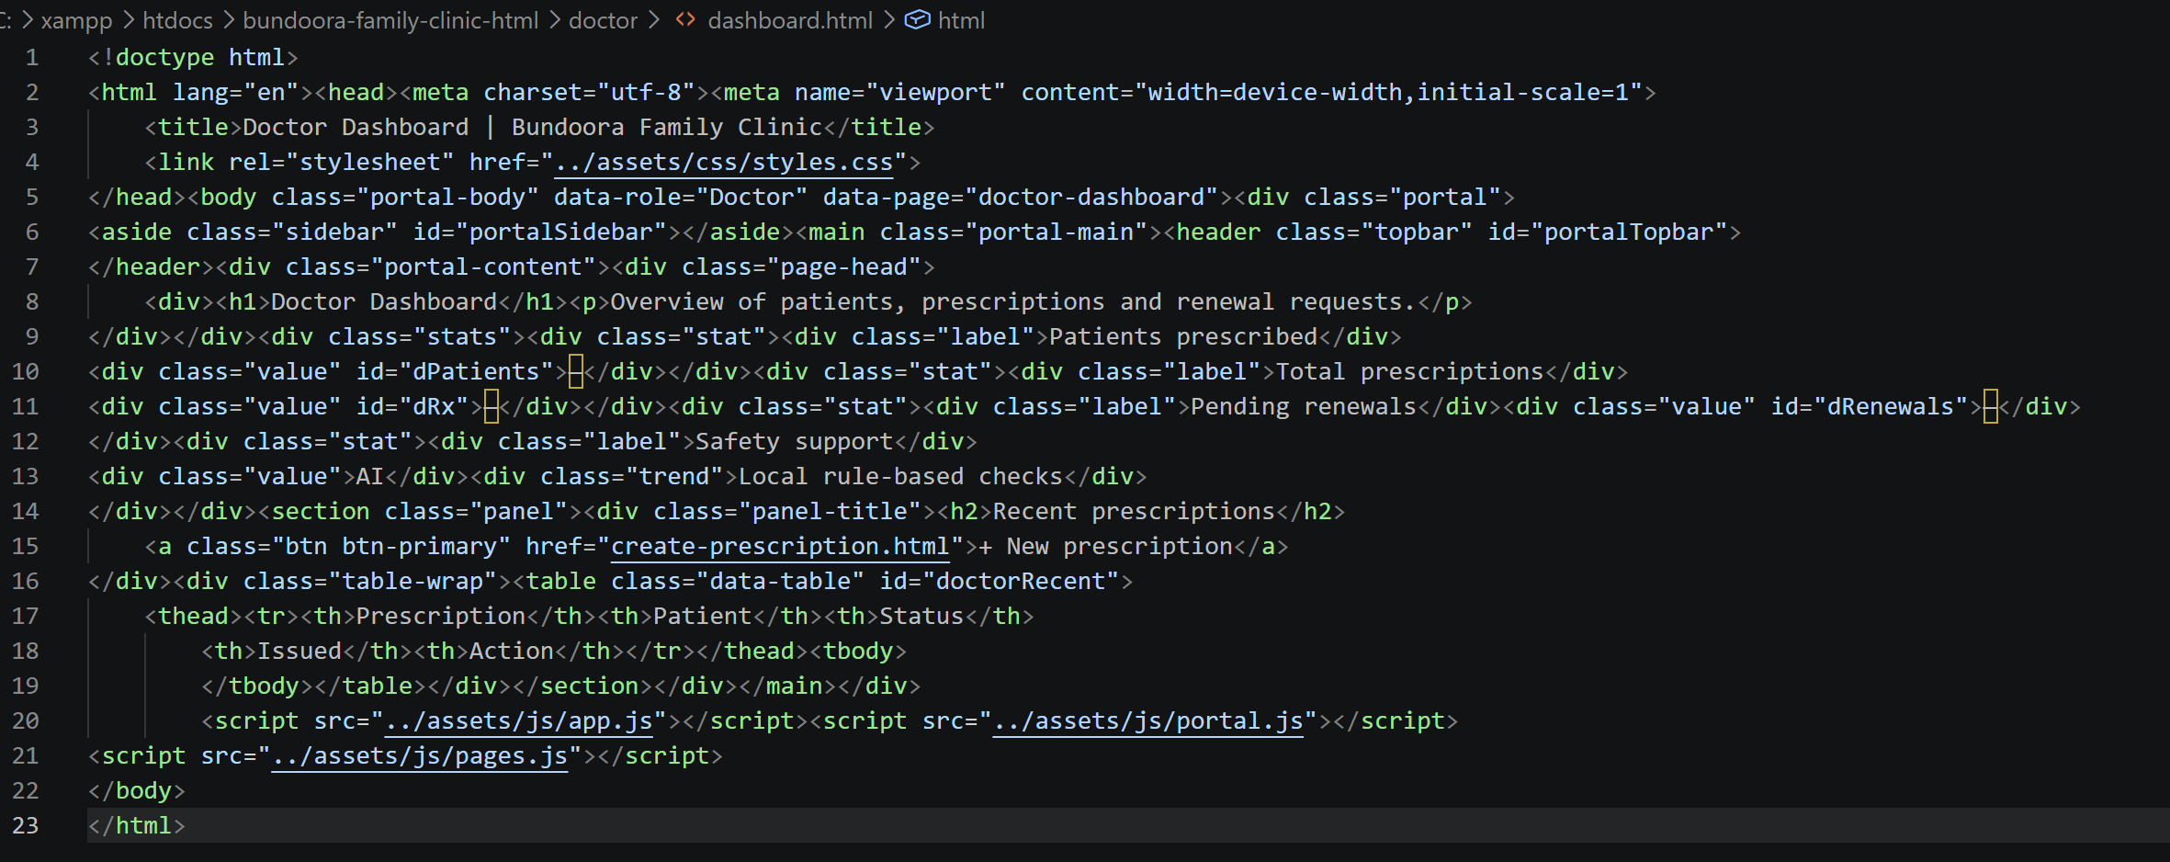

All portals share a common layout: a sidebar (left) listing the modules available to the role, a top bar showing the signed-in user and notifications, and the content area containing the page title, summary statistics and data panels.
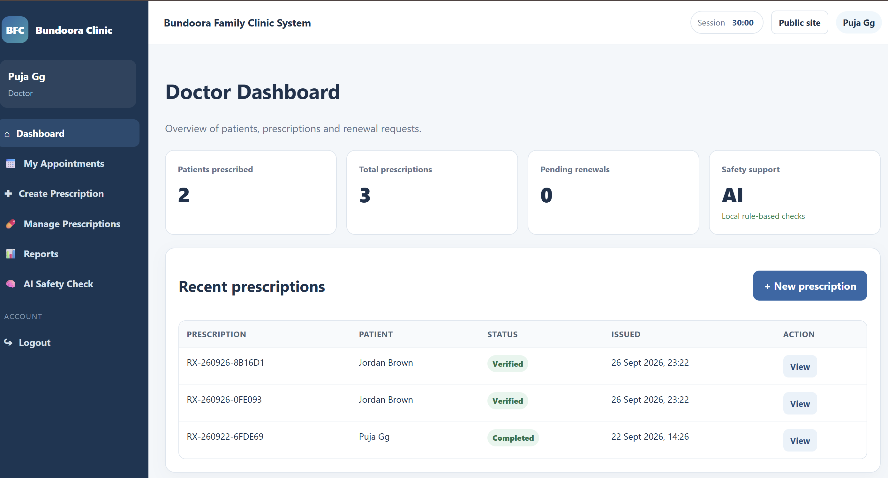Figure : Common portal layout with sidebar, top bar and content area

2. Patient Portal

2.1 Patient Dashboard

[Code]
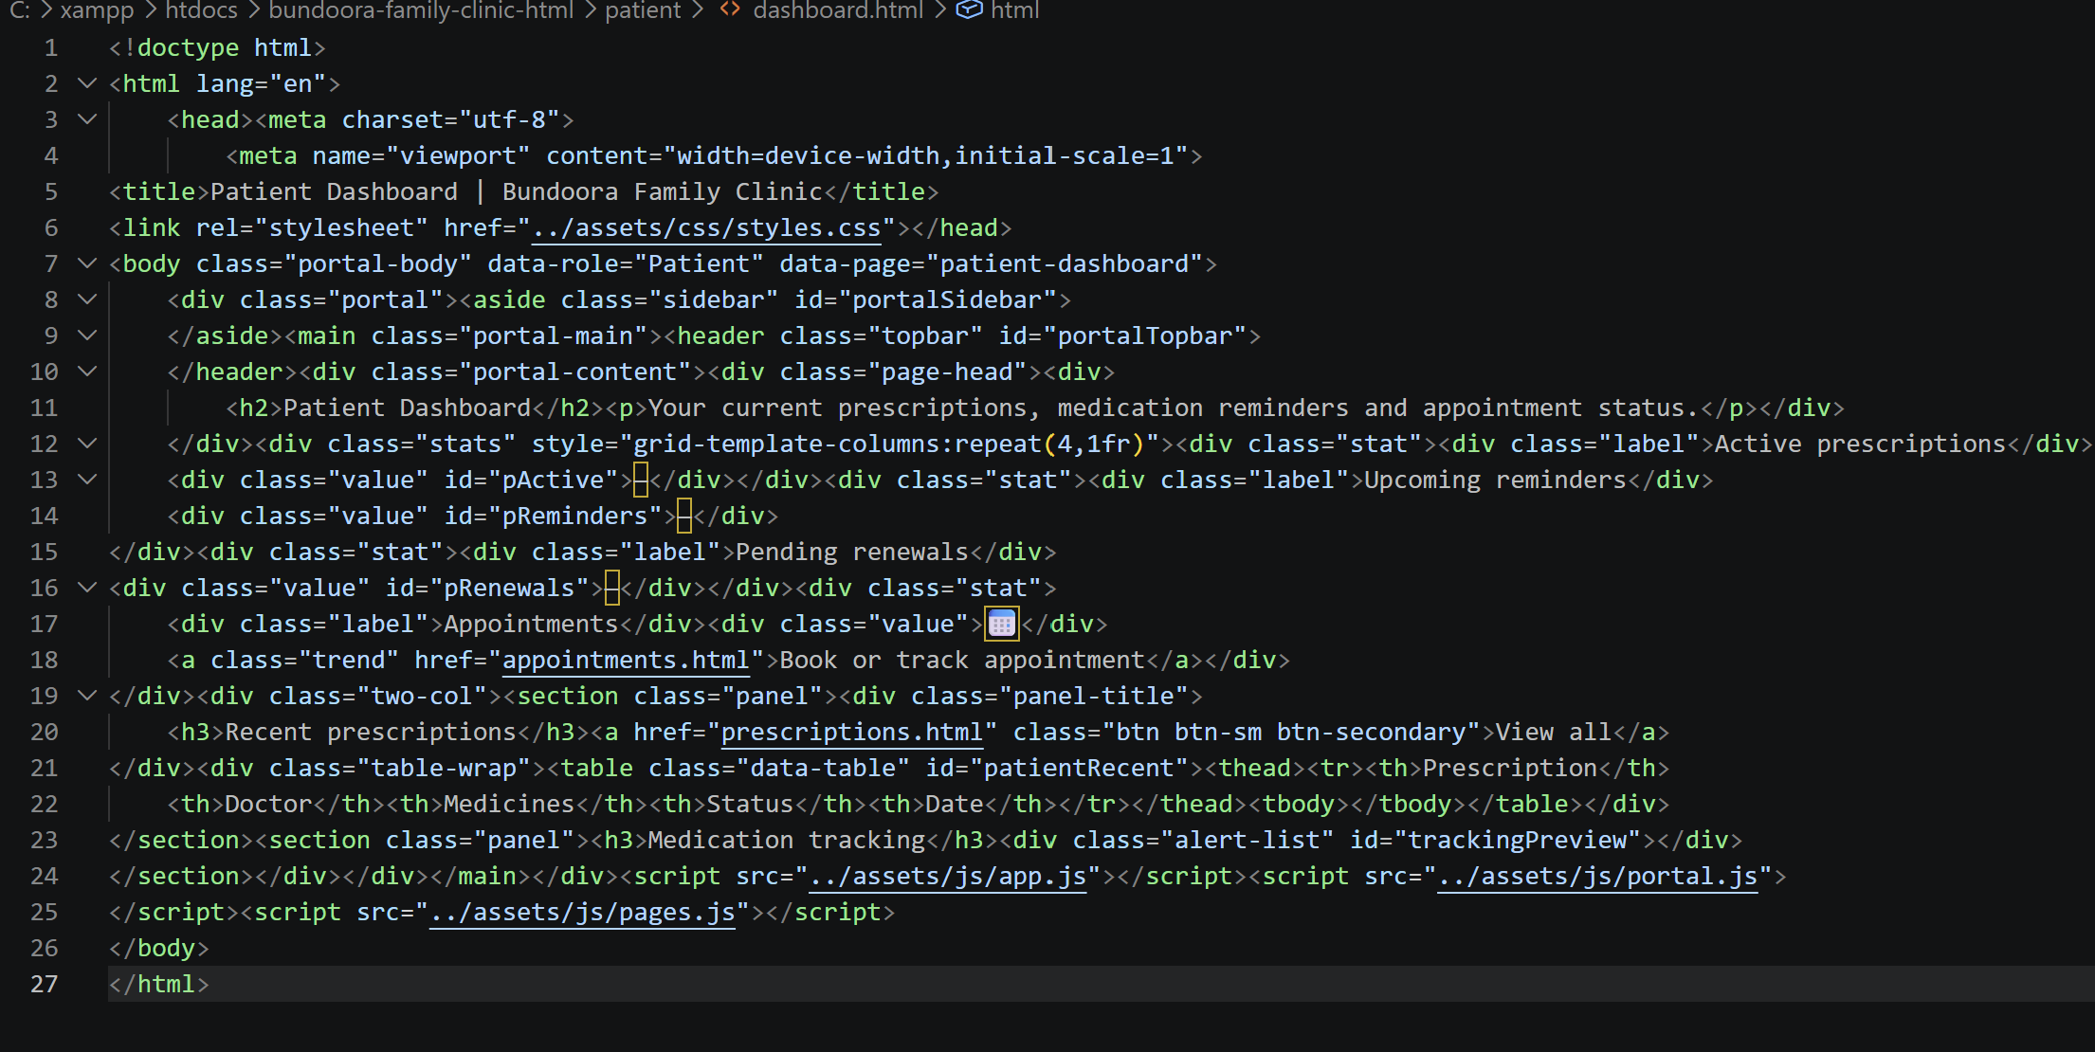

The dashboard summarises the patient's current care and provides shortcuts to common tasks.
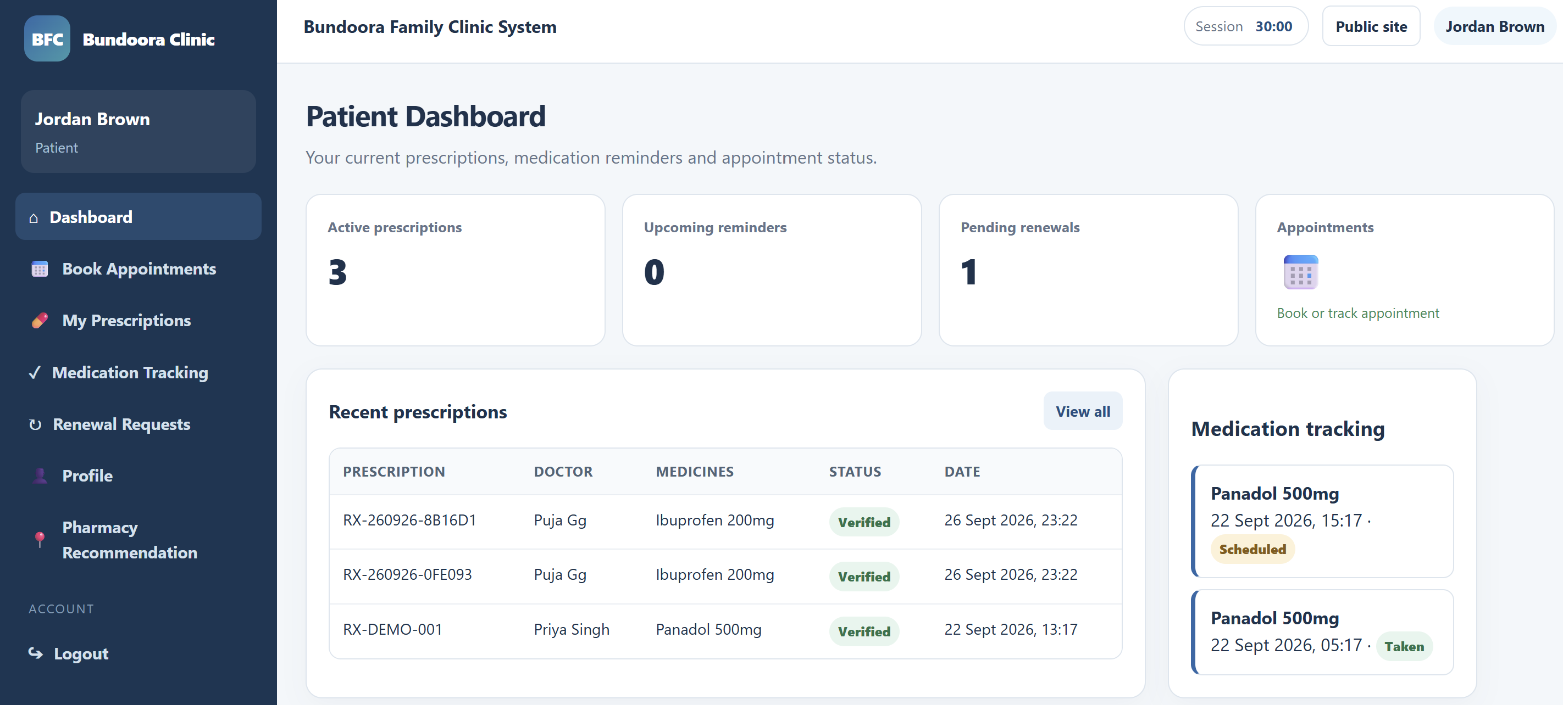
Fig: Patient dashboard

2.2 Booking an Appointment

[Code]
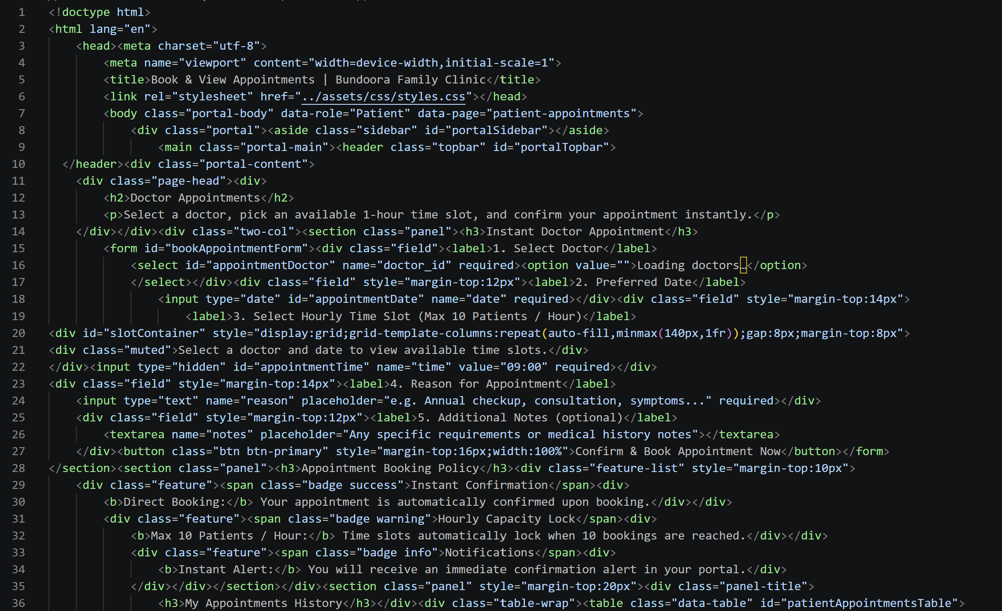
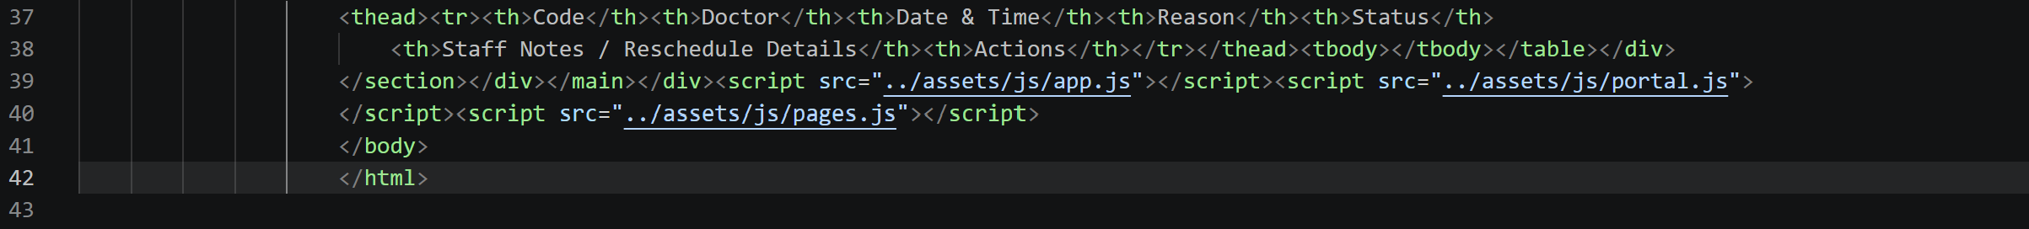
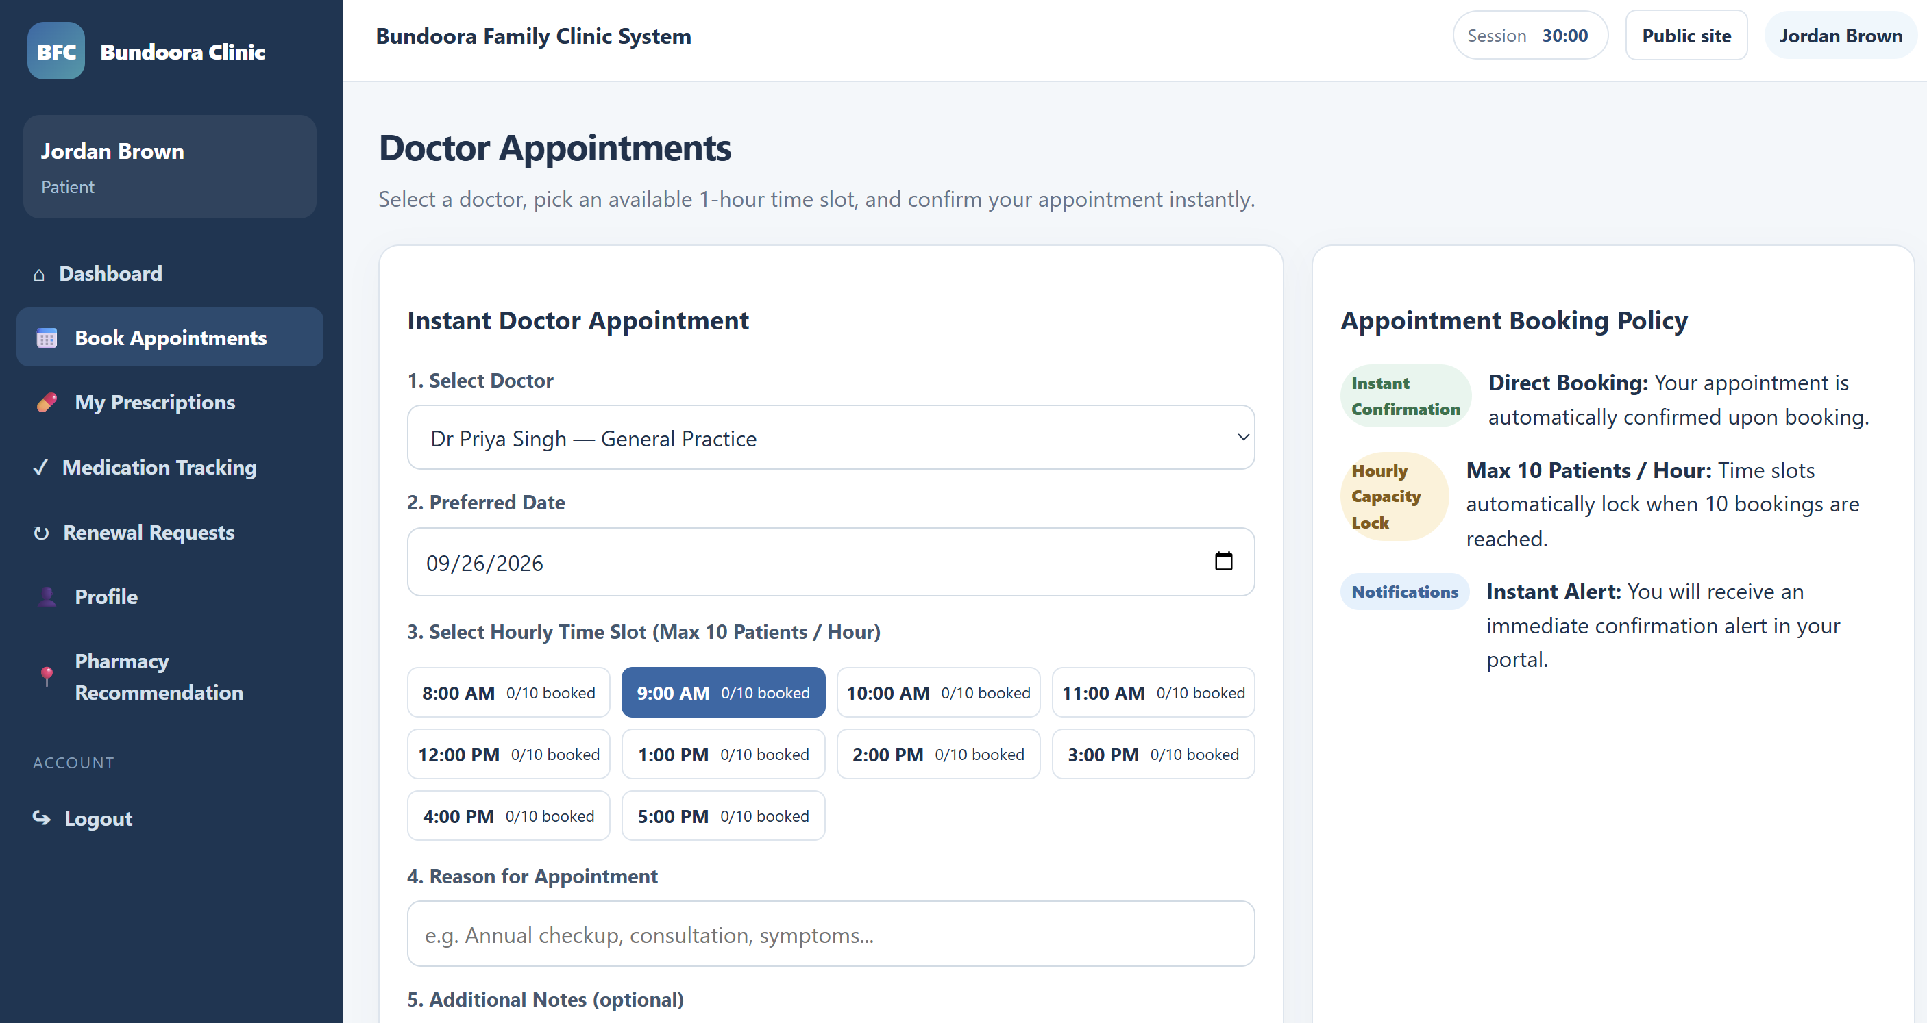Fig: Doctor Appointments booking form

2.3 Viewing and Cancelling Appointments
The My Appointments History table lists every appointment with its status and any notes from clinic staff. Figure 8 shows how an appointment's status can change.
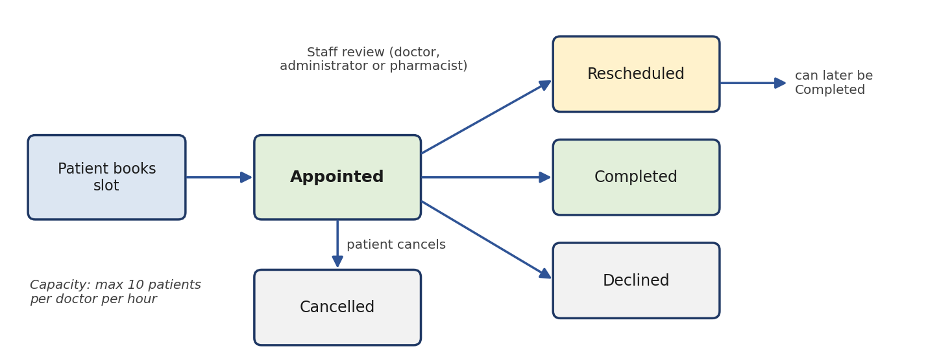

Fig: Appointment status transitions
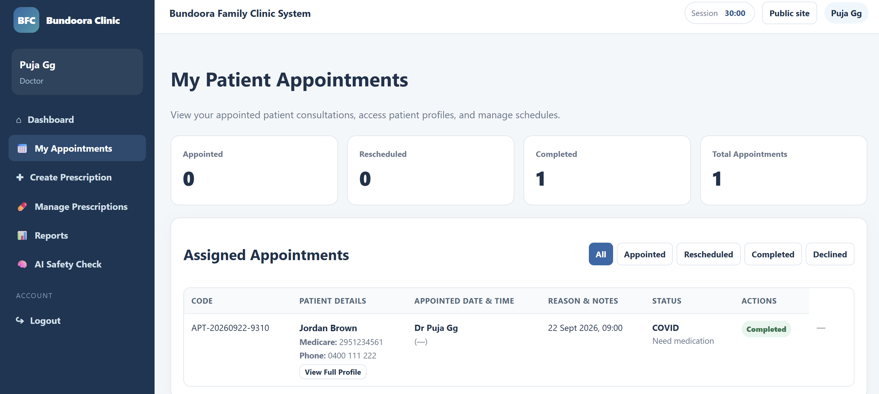
Fig: Appointment view from doctor’s portal

2.4 Viewing Prescriptions

[Code]
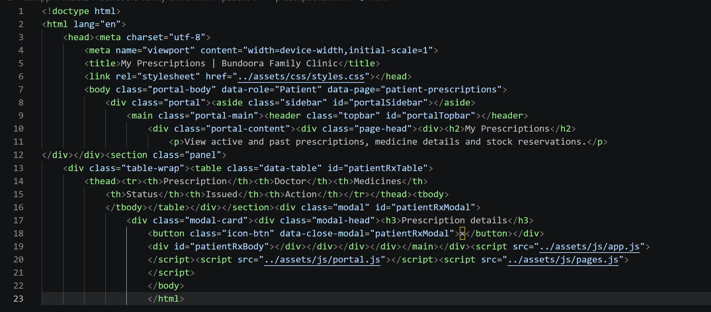

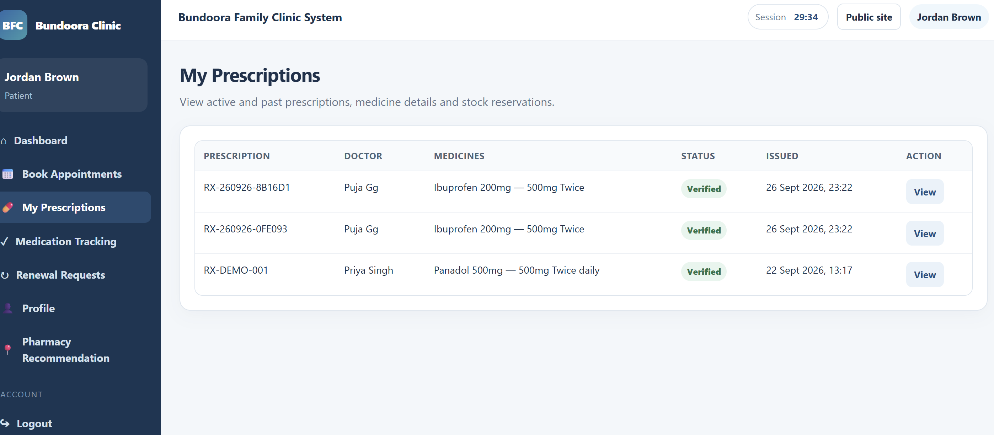Fig: My Prescriptions list and prescription details window

2.5 Recording Medication Doses

[Code]
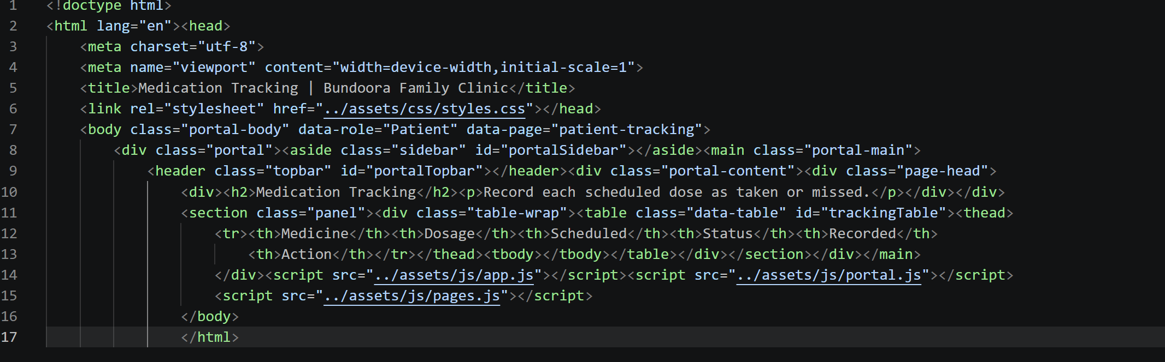

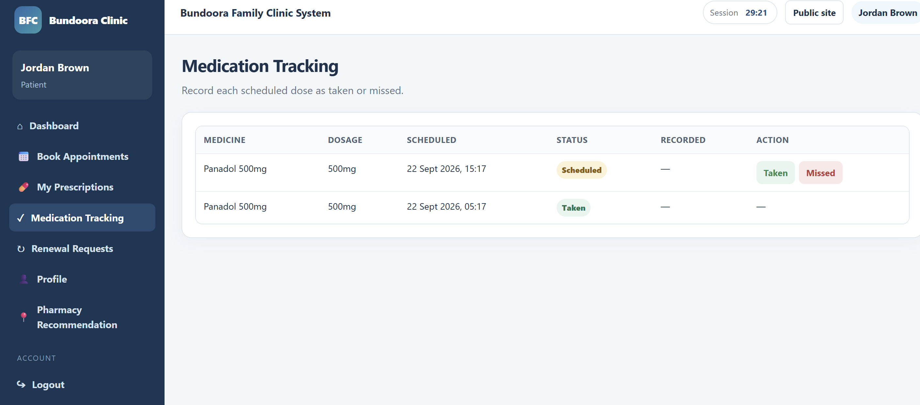
Fig: Medication Tracking details

2.6 Requesting a Prescription Renewal

[Code]
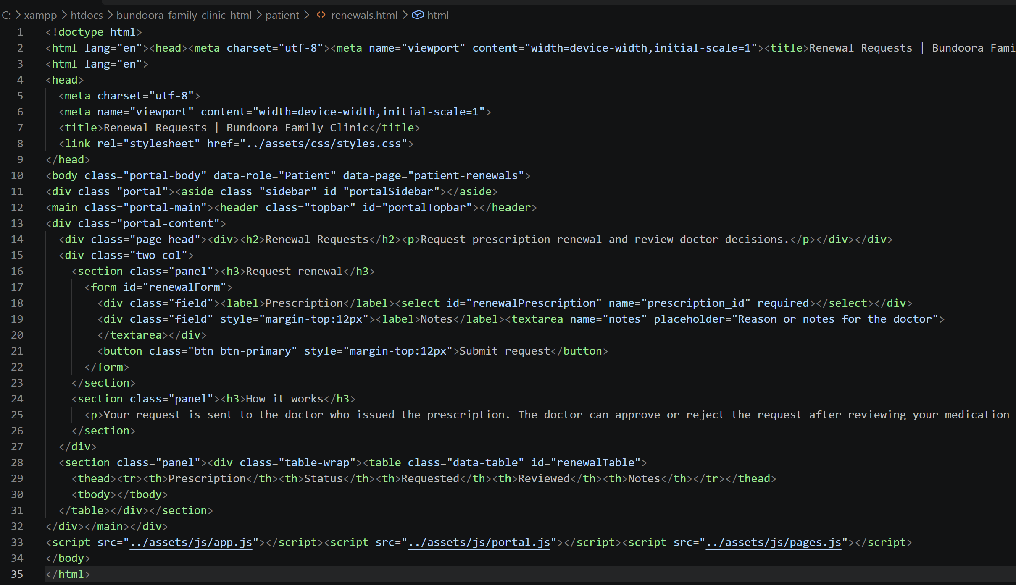

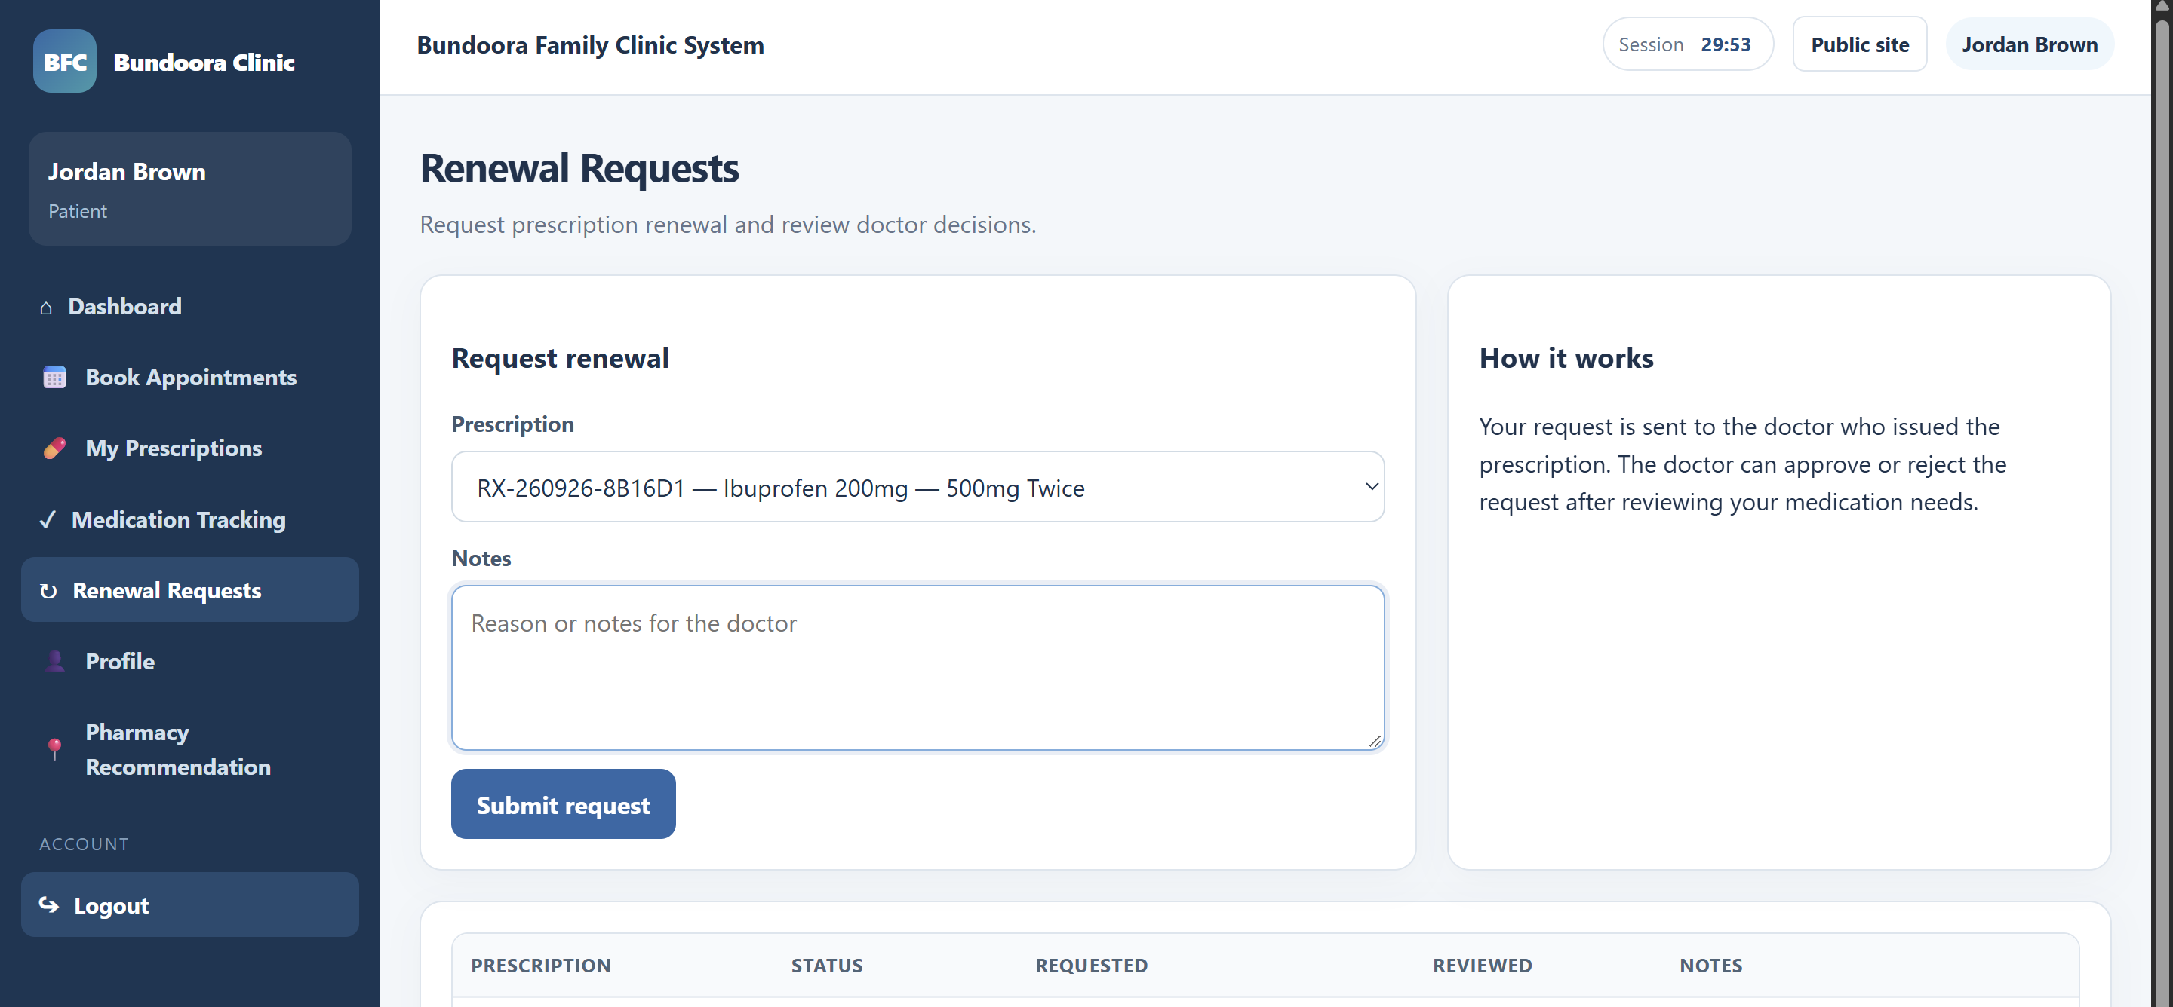
Fig: Renewal Request window

2.7 Finding a Partner Pharmacy

[Code]
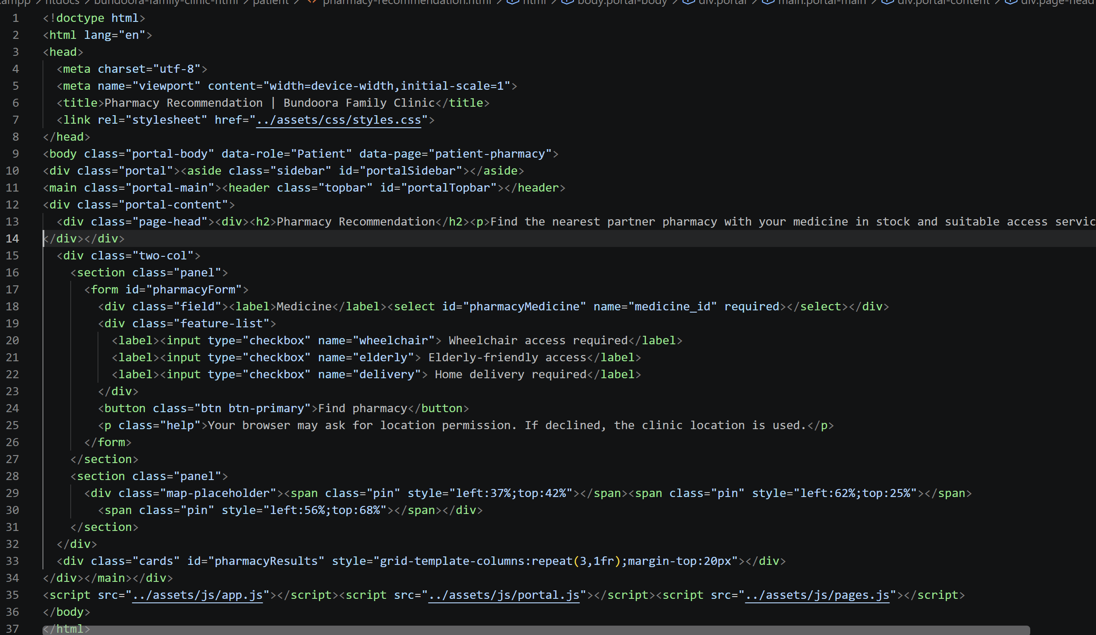

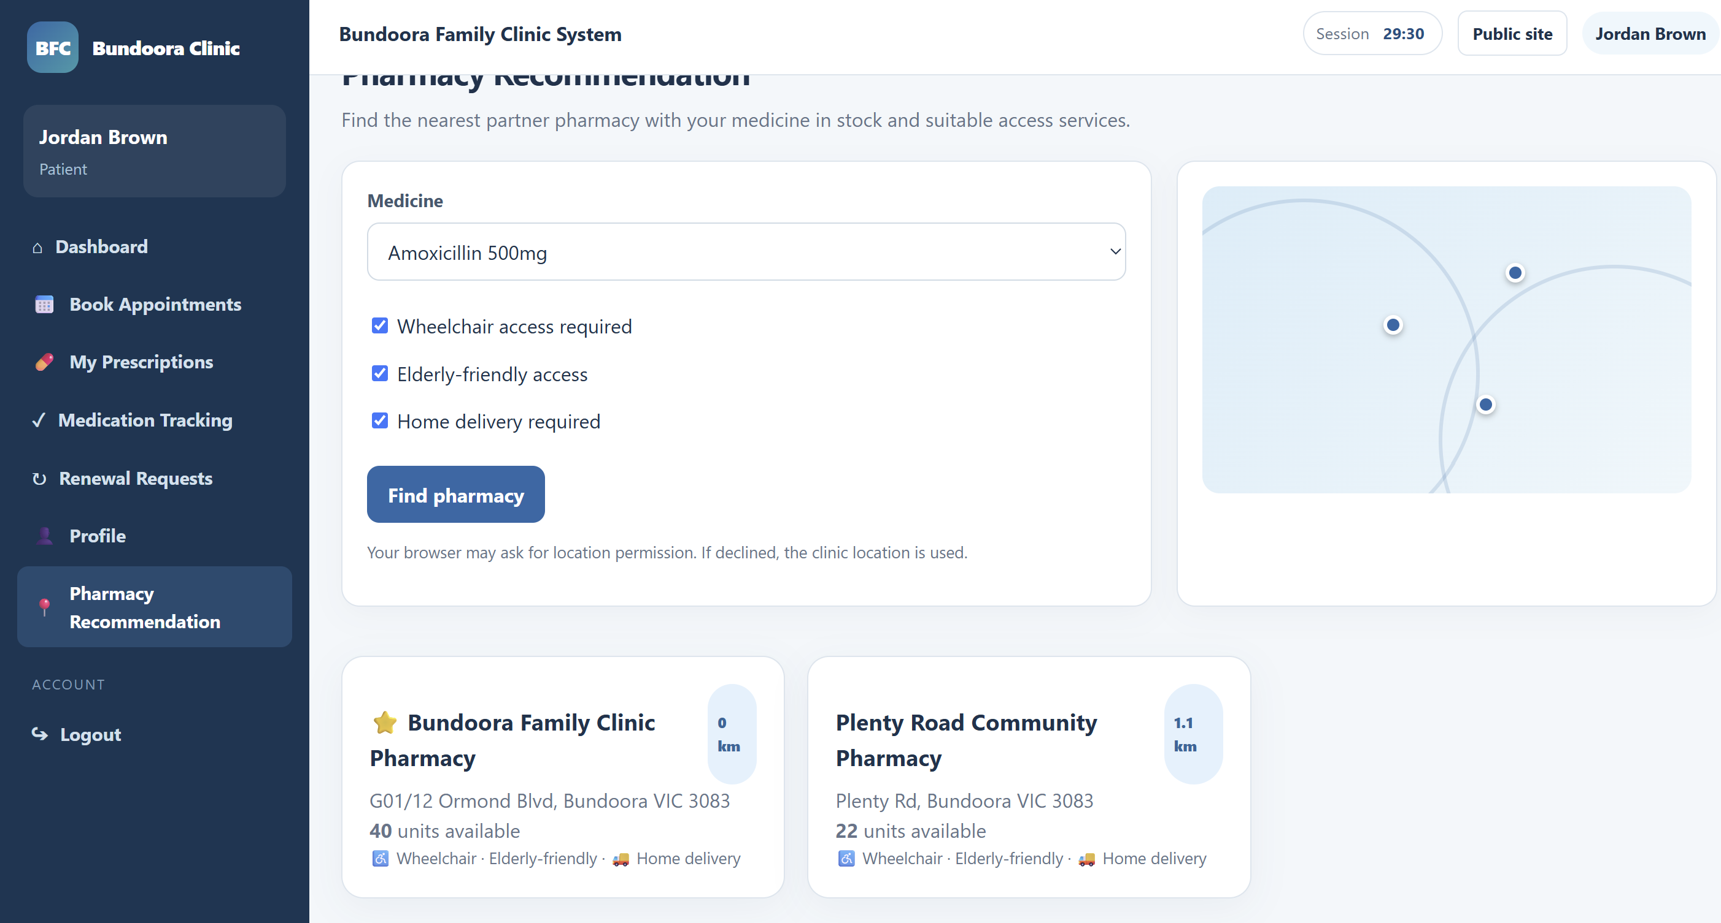Figure: Pharmacy Recommendation search and results

2.8 Updating Personal Details

[Code]
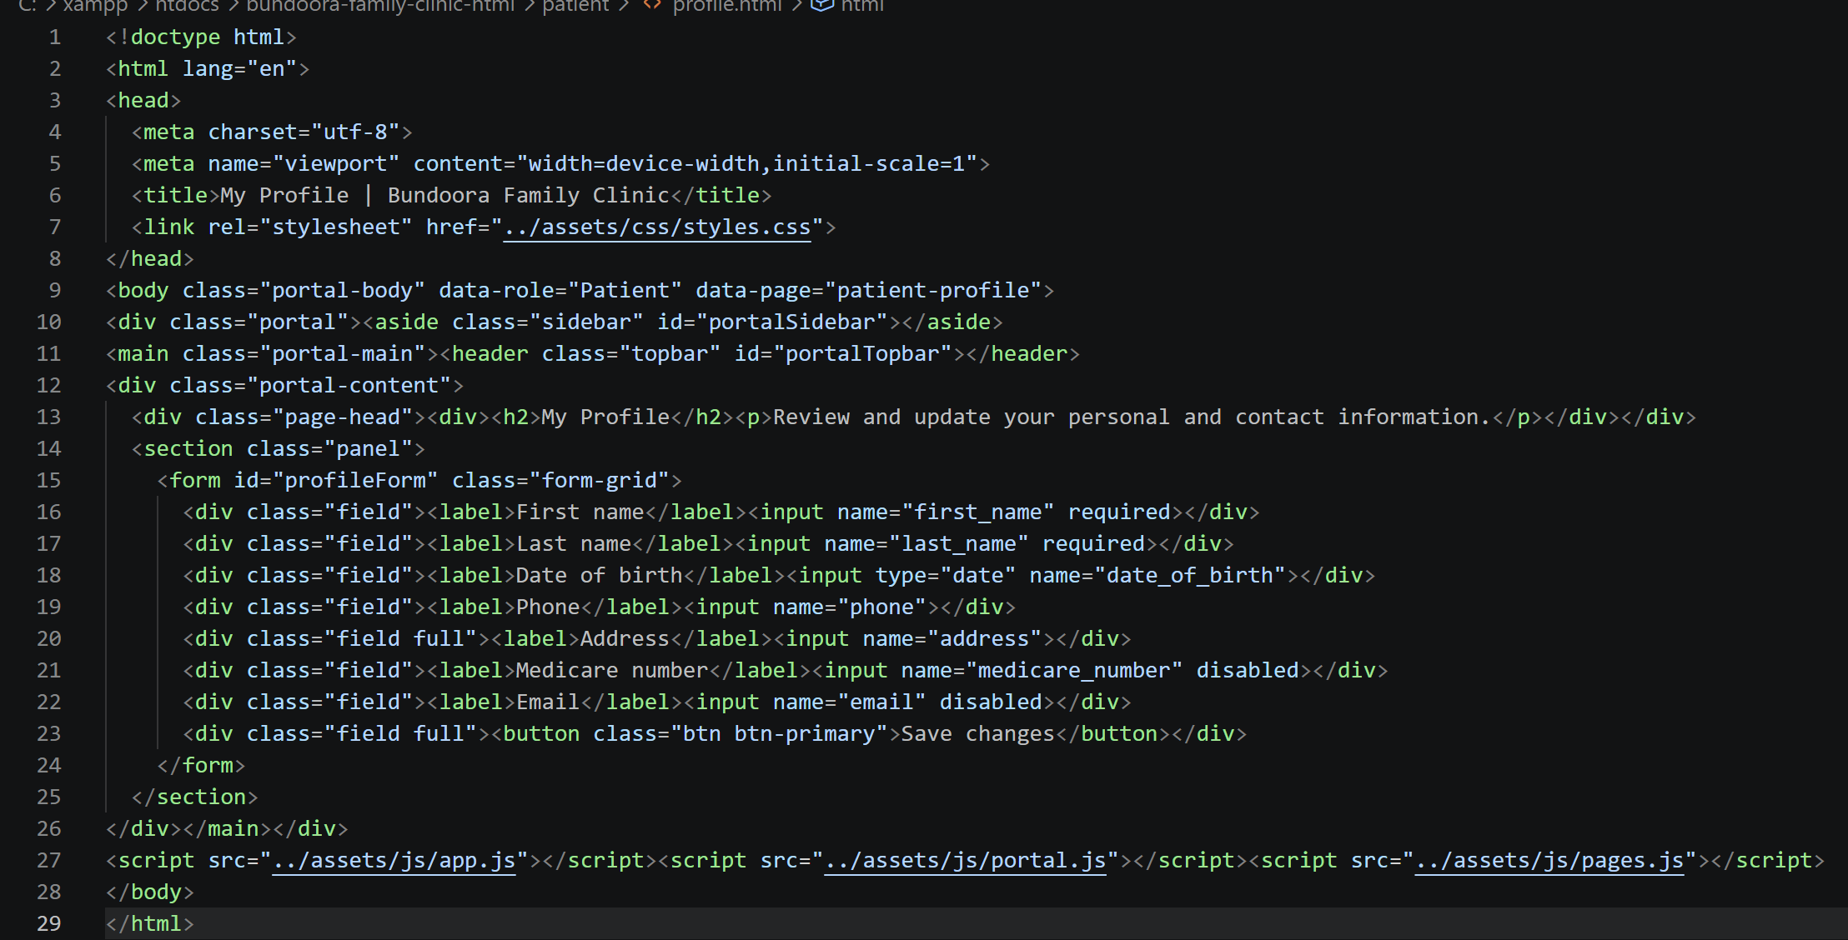

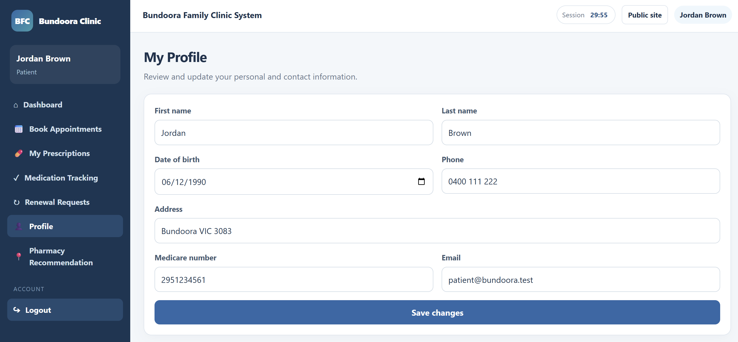Fig: Profile fields

